A risk assessment should be completed to determine the controls required for protecting workers against hazards in the workplace. This also applies to COVID-19. On the following page, a sample risk assessment is presented, which can be used in your workplace. In this assessment factors such as the likelihood of exposure and the consequences of exposure are considered. Likelihood of exposure can be thought of as how often an employee contacts others or surfaces, whereas the consequence of exposure can be thought of as the resulting effects from being exposed to the hazard of COVID-19. The following factors should also be considered when carrying out the risk assessment:

**What are the areas of concern?**

* Who could potentially be exposed?
* What tasks are we most concerned with?
  + Have you considered what tools or equipment are shared?
  + Have you considered common areas, such as the lunchroom, break rooms, meeting rooms, locker rooms?

**How many employees could potentially be exposed?**

* How many employees would normally be in a room?
* Is there enough space to allow for physical distancing?

**What are the consequences of exposure?**

* Given the current information available from our provincial health authorities, what are the predicted health consequences? (Insignificant, Minor, Moderate, Major, Extreme)

Refer to the Sample Risk Assessment, on the following page, to help you carry out your own risk assessment for COVID-19. It is best to have the training and knowledge in carrying out a risk assessment. Also, it is best practice to have representation from all levels of the organization, including the Joint Health and Safety Committee (JHSC) or the Worker Health and Safety Representative, to complete this assessment.

The steps are:

1. Identify the areas/activities/positions of concern. You can refer to the Guidance Document on   
   Page 6, for exposure scenarios.
2. Rank the consequence and likelihood of exposure using the Risk Assessment Matrix on page 5, to determine and input the Initial Risk Rating (Very Low, Low, Medium, High, and Extreme).
3. Select appropriate controls for your workplace to reduce the risk. You can refer to the Guidance Document on Page 6, for possible controls and input your selected controls into the tool.
4. Re-evaluate your risk with your new controls in place. Rank the consequence and likelihood of   
   exposure using the Risk Assessment Matrix on Page 5, to determine and input the Residual Risk Rating (Very Low, Low, Medium, High, and Extreme).
5. Is your new risk rating acceptable for your workplace?

If yes, proceed to Step 6.  
If no, what additional controls can be implemented to lower the risk further.   
Repeat Step 4 onwards, until an acceptable risk rating is achieved.

1. Repeat the process for the remaining areas of concern.
2. When all areas are completed, this document should be circulated and communicated to all employees, including the JHSC. Keep a record on file for inspection purposes.
3. Ensure the completion of this assessment is documented in the minutes of the next JHSC meeting  
   .

|  |  |  |  |  |  |  |  |  |  |  |  |  |  |
| --- | --- | --- | --- | --- | --- | --- | --- | --- | --- | --- | --- | --- | --- |
| Sample Risk Assessment Form | | | | | | *Activity/Job/Task: Working in the main office, routine activities* | | | | | | | |
| Prepared by | | Date Prepared | | Document No. | | Revision No. | | | Revision Date | |  | Dept./Location/Area | |
| Jane Doe | | May 20, 2020 | | 123.123 | |  | |  |  |  | |  |  |
| **Uncontrolled Risk of Hazard** | | | | | | **Controlled Risk of Hazard** | | | | | | | |
| **HAZARD** | | Workers affected (#) | Likelihood | Consequences | Initial Risk Rating | **CONTROL MEASURES** | | | | Likelihood | | Consequences | Residual Risk Rating |
| B | Biological | EL | Elimination | |  |
| C | Chemical | S | Substitution | |  |
| P | Physical | EN | Engineered | |  |
| Ps | Psychosocial | A | Administrative | |  |
|  |  | P | PPE |  |  |
| B | SARS-CoV-2 | All staff (18) | Most Likely | Extreme | High | EL EN EN A  A  PPE | Working from home Barrier for reception desk  Single occupancy office rooms  COVID 19 Policy, Signage  Sanitization Program  N/A | | | Rare | | Extreme | Low |
|  |  |  |  |  |  |  |  | | |  | |  |  |
|  |  |  |  |  |  |  |  | | |  | |  |  |
|  |  |  |  |  |  |  |  | | |  | |  |  |
|  |  |  |  |  |  |  |  | | |  | |  |  |
|  |  |  |  |  |  |  |  | | |  | |  |  |

|  |  |  |  |  |  |  |  |  |  |  |  |  |  |
| --- | --- | --- | --- | --- | --- | --- | --- | --- | --- | --- | --- | --- | --- |
| Risk Assessment Form | | | | | | *Activity/Job/Task:* | | | | | | | |
|
|
| Prepared by | | Date Prepared | | Document No. | | Revision No. | | | Revision Date | |  | Dept./Location/Area | |
|  | |  | |  | |  | |  |  |  | |  |  |
| **Uncontrolled Risk of Hazard** | | | | | | **Controlled Risk of Hazard** | | | | | | | |
| **HAZARD** | | Workers affected (#) | Likelihood | Consequences | Initial Risk Rating | **CONTROL MEASURES** | | | | Likelihood | | Consequences | Residual Risk Rating |
| B | Biological | EL | Elimination | |  |
| C | Chemical | S | Substitution | |  |
| P | Physical | EN | Engineered | |  |
| Ps | Psychosocial | A | Administrative | |  |
|  |  | P | PPE |  |  |
|  |  |  |  |  |  |  |  | | |  | |  |  |
|  |  |  |  |  |  |  |  | | |  | |  |  |
|  |  |  |  |  |  |  |  | | |  | |  |  |
|  |  |  |  |  |  |  |  | | |  | |  |  |
|  |  |  |  |  |  |  |  | | |  | |  |  |
|  |  |  |  |  |  |  |  | | |  | |  |  |
|  |  |  |  |  |  |  |  | | |  | |  |  |

# Template

|  |  |  |  |  |  |  |
| --- | --- | --- | --- | --- | --- | --- |
| Risk Assessment Matrix | | **Consequence of Exposure** | | | | |
| **Insignificant** | **Minor** | **Moderate** | **Major** | **Extreme** |
| **Likelihood of Exposure** | **Certain**  Continuous close contact with infected workers/surfaces all day; within 2 m (6 ft.) | **Low** | **Medium** | **High** | **High** | **Extreme** |
| **Most Likely**  Close contact with infected workers/surfaces several times an hour; within 2 m (6 ft.) | **Low** | **Medium** | **Medium** | **High** | **High** |
| **Likely**  Close contact with infected workers/surfaces several times a day; within 2 m (6 ft.) | **Very Low** | **Low** | **Medium** | **Medium** | **High** |
| **Unlikely**  Minimum contact with infected workers/surfaces several times a day;  more than 2 m (6 ft.) | **Very Low** | **Low** | **Low** | **Medium** | **Medium** |
| **Rare**  Minimal contact with infected workers/surfaces, once a day. | **Very Low** | **Very Low** | **Very Low** | **Low** | **Low** |

The legend below explains how each risk level is evaluated.

|  |  |  |
| --- | --- | --- |
| **Extreme** |  | Very High risk of exposure |
| **High** |  | High risk of exposure |
| **Medium** |  | Medium risk of exposure |
| **Low** |  | Low Risk of exposure |
| **Very Low** |  | Very low risk of exposure |

# Guidance document

On the following pages, examples of scenarios are given which can be helpful in identifying where employees can be exposed. There are also examples of controls, which can be used in your workplace. It is important to follow the hierarchy of controls, when selecting controls for your application:

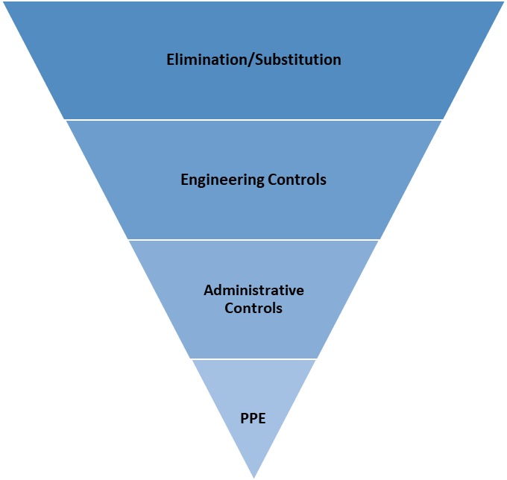

**Most Effective**

**Least Effective**

|  |
| --- |
| TYPES OF EXPOSURES |
| Through contact with employees |
| Through contact with the public |
| Through contact of vehicles |
| Through handling of materials |
| Through contact of tools, machinery, and equipment |
| Through contact of personal protective equipment (PPE) |
| Through sharing common spaces with others (change rooms, lunchrooms, washrooms) |
| Through work on computer, desk, or office |
| When handling cash |
| When passing others in hallways or aisles |
| When performing first aid treatment |
| When completing tasks. |
| When completing a two-person task |
| When using worksite facilities |
| When sanitizing surfaces, tools, machinery, and equipment |
| When performing maintenance on equipment |
| When operating machinery and processes |
| When operating mobile equipment |
| When operating forklift |
| Working in an office, routine activities |

|  |
| --- |
| CONTROLS | ELIMINATION |
| *Reducing number of people at workplace* |
| Working offsite or remotely |
| Conduct meetings virtually |
| Rescheduling work tasks |
| Established and posted occupancy limits for common areas |
| Changes to how tasks are done |
| Limiting or prohibiting visitors |
| *Physical distancing:* |
| Occupancy limits by work area |
| Maintain two-meter distance |
| Work schedules (adjust times) |
| Work schedules (rotate) |
| Change operating hours |
| Use outdoor spaces |
| Directional flow in work areas |

|  |
| --- |
| CONTROLS | ENGINEERING |
| Air filtration |
| Barriers: partitions plexiglass, plastic |
| Enclosures |
| Tools or equipment replacement |
| Robotics/automation |
| Ventilation |

|  |
| --- |
| CONTROLS | ADMINISTRATIVE |
| *Assessment & Control* |
| Exposure control plan |
| Pandemic Plan |
| Respirator Protection Program |
| WHMIS Program |
|  |
| *Policies/Rules/Guidelines* |
| Reporting Symptoms in the Workplace |
| Policy for Returning Travelling |
| Visitor policy |
| Working alone policy |
| Working from home policy |
| Industry-specific protocols |
| Designated delivery areas |
| Single use disposable products |
| Pods of workers who work together exclusively |
| First Aid Attendant OFAA protocols |
| Violence prevention program |
| Conduct toolbox talks in smaller groups |
| Sanitization Program |